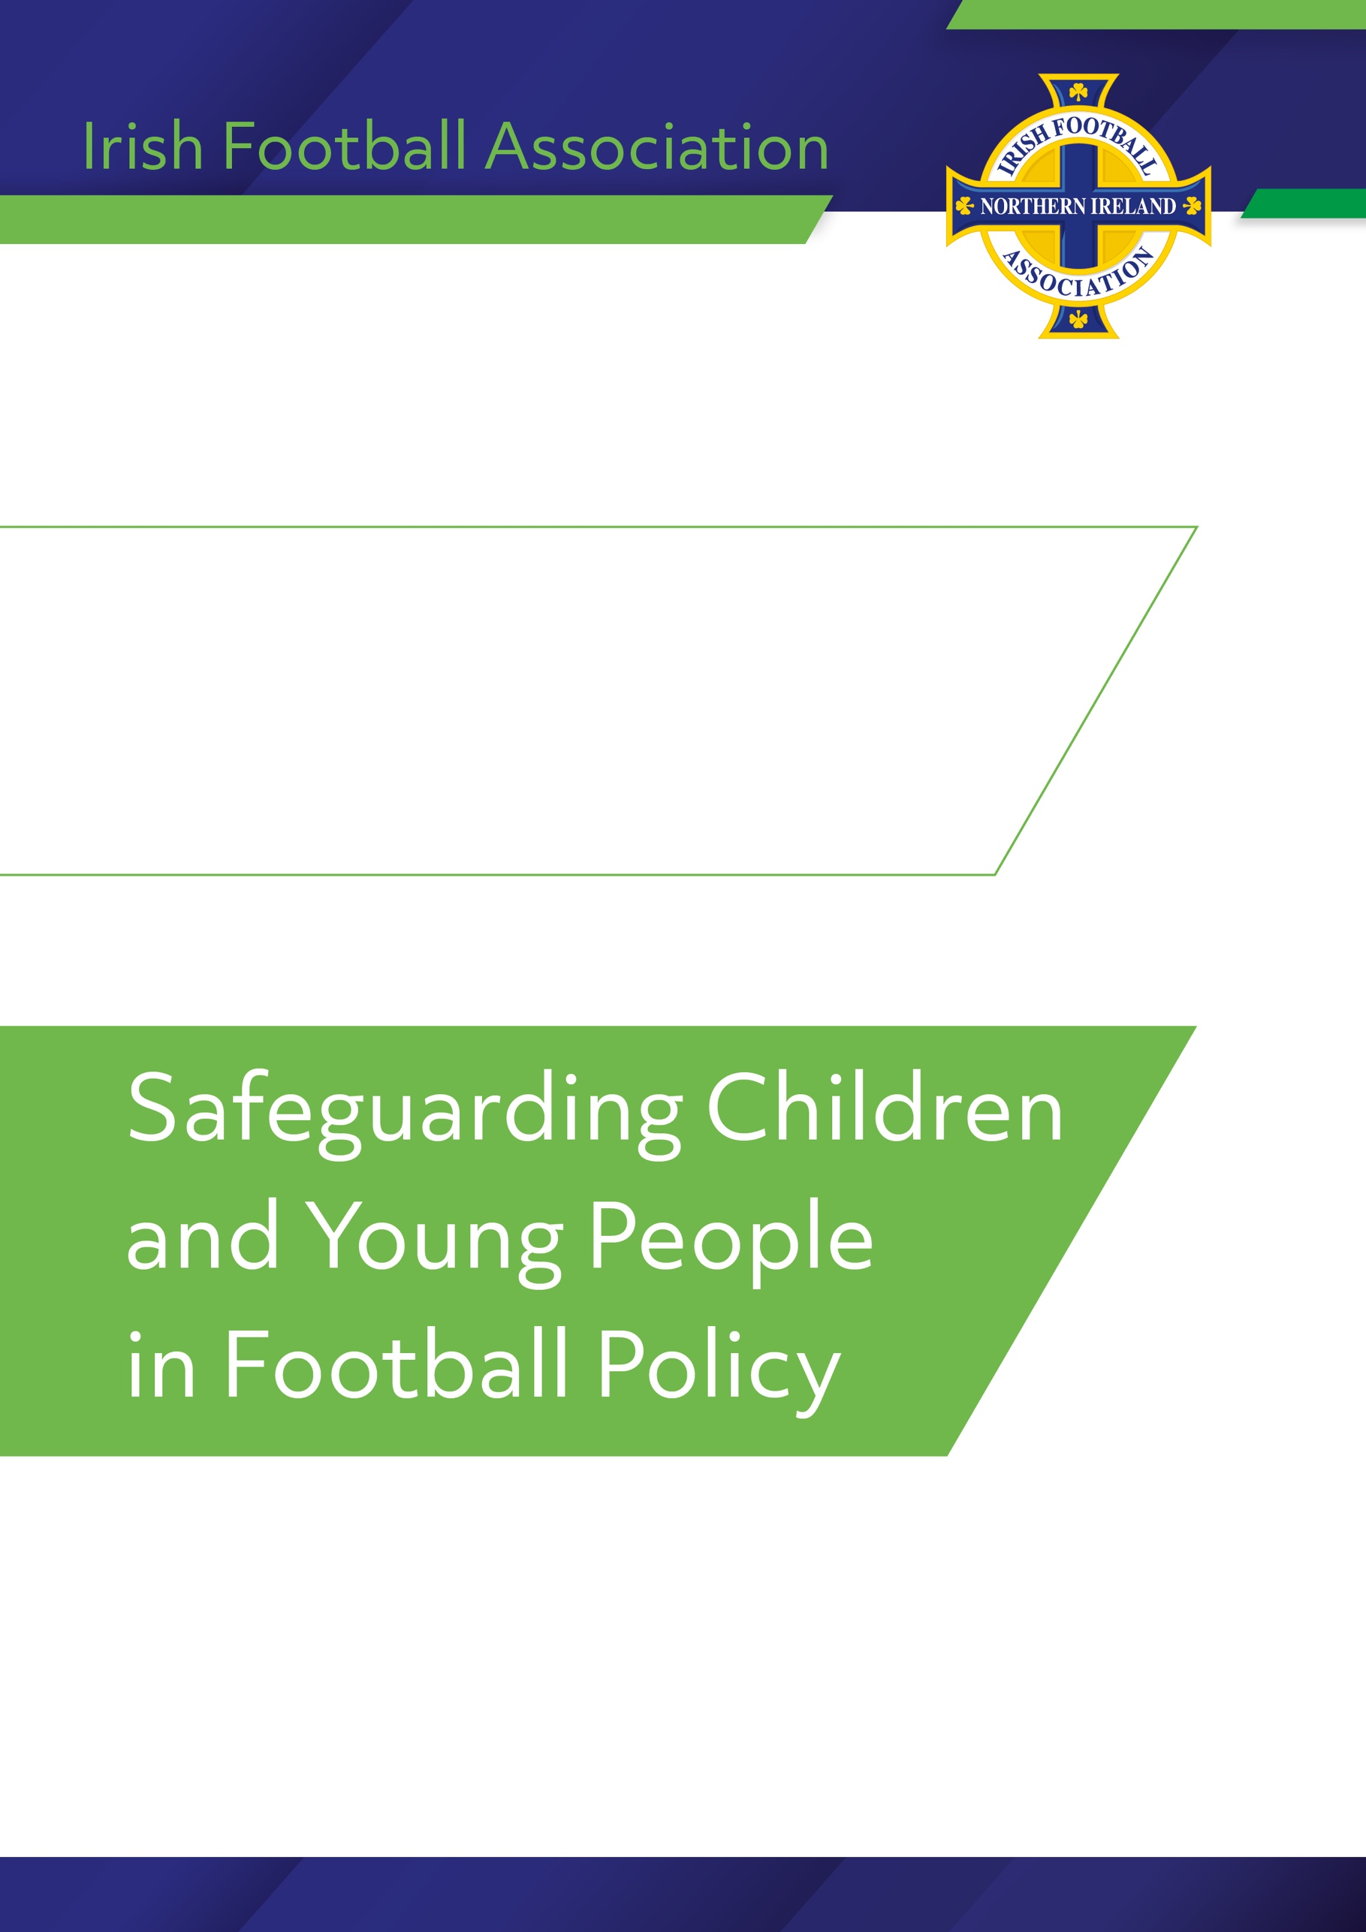

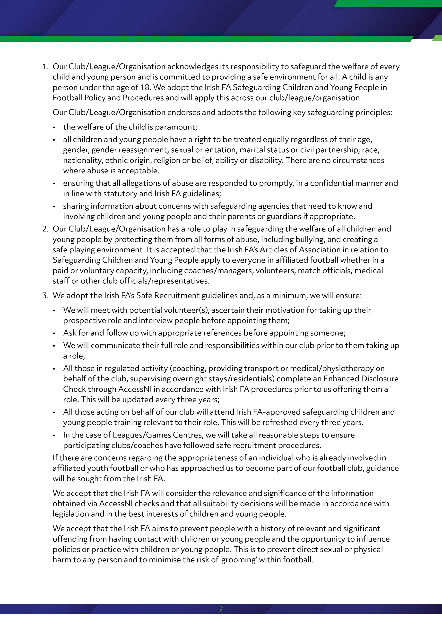

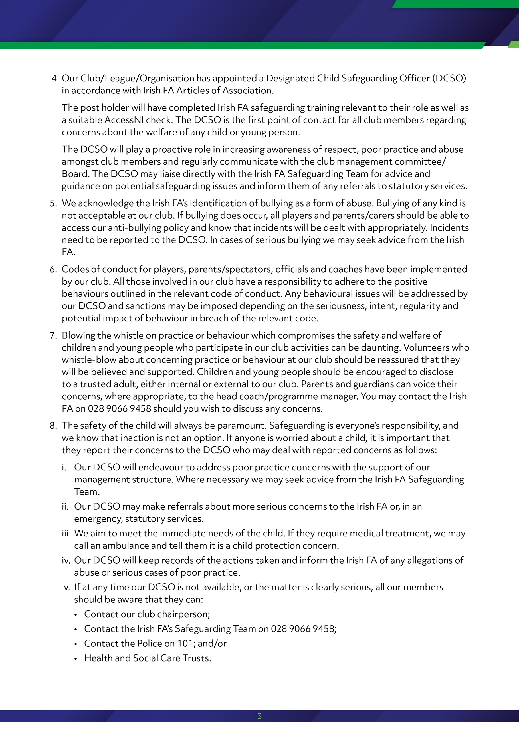

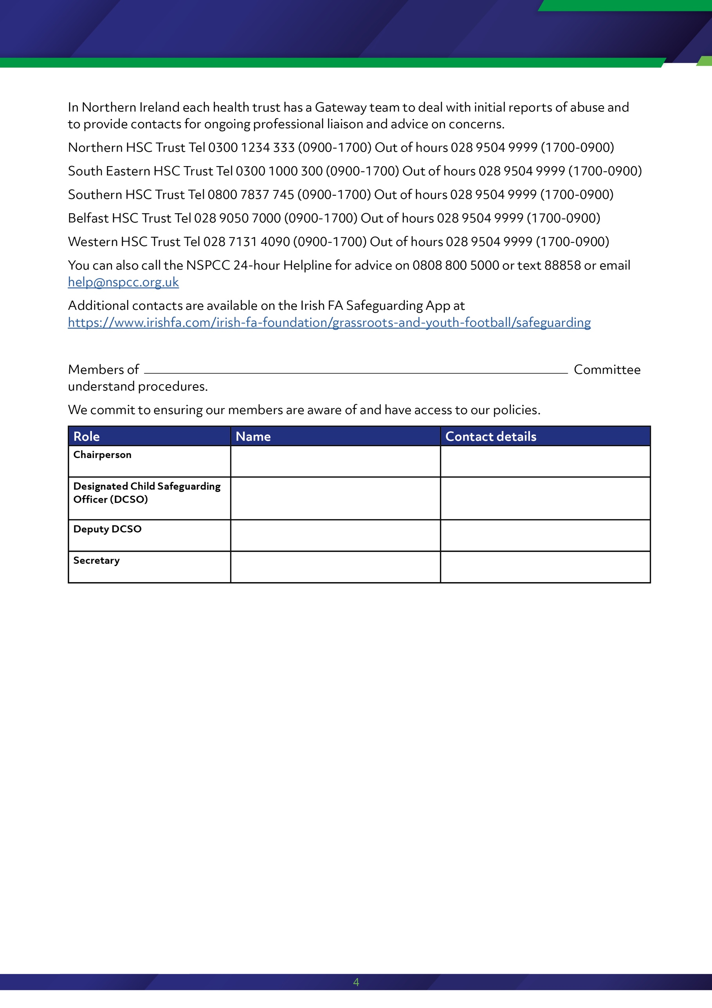
Enniskillen Rangers F.C.
Mark Gallagher
07599830926
Lisa Crawford
07834587890
Lisa Gallagher
07542500454
Davy Robinson
07751307856

